OpenIntro Stats Section (3.4.3 and 3.4.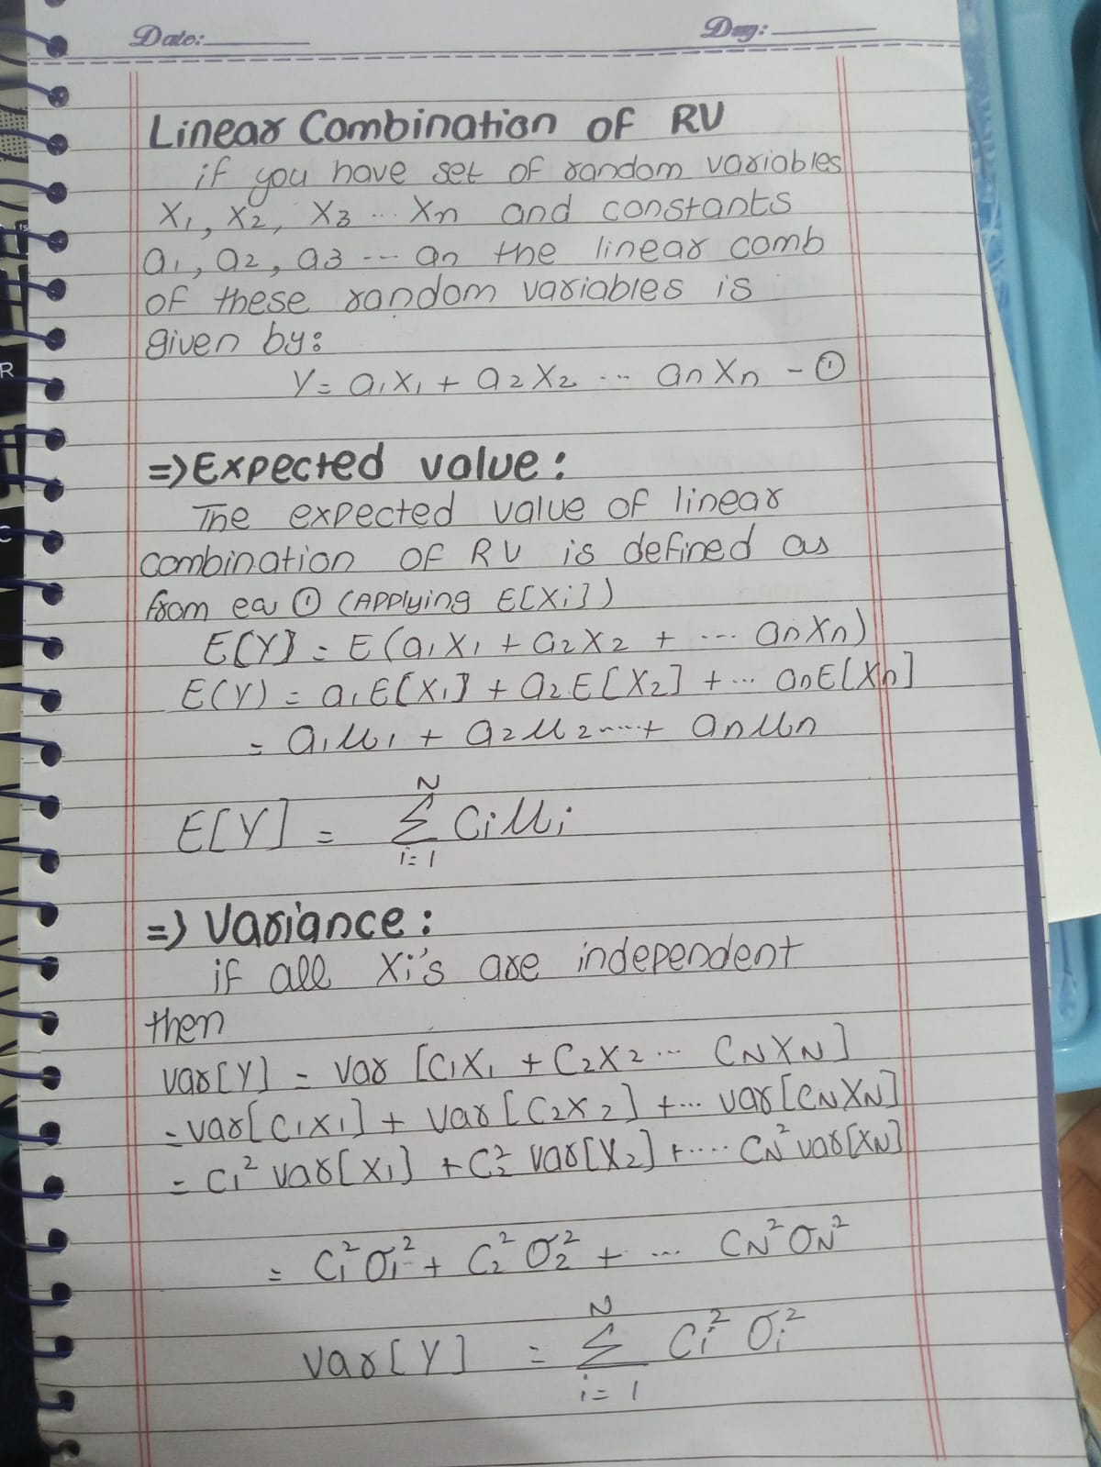
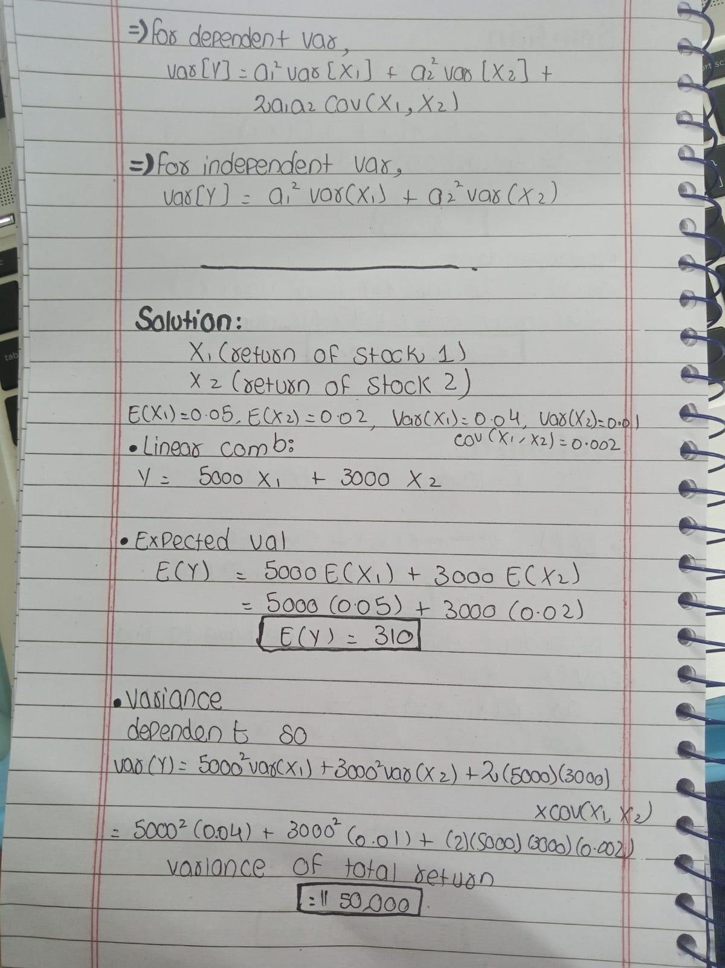

—----------------------------------------------------------------------------------------------------------------------------

Practice Question 1:
Suppose X1​ and X2​ are random variables representing the monthly returns of two stocks. Let X1​ have a mean of 0.05 and variance of 0.04, and X2​ have a mean of 0.02 and variance of 0.01. The covariance between X1 and X2 is 0.002. If you invest $5000 in stock 1 and $3000 in stock 2, find the expected return and the variance of your total investment return for the month.

Practice Question 2:
Let X1 and X2 be independent random variables representing the annual income from two separate investments. Suppose:
- E(X1)=10,000
- Var(X1)=25,000,000
- E(X2)=15,000
- Var(X2)=16,000,000
Calculate the expected total income and the variance of the total income from both investments if:
Y= 2X1 + 3X2
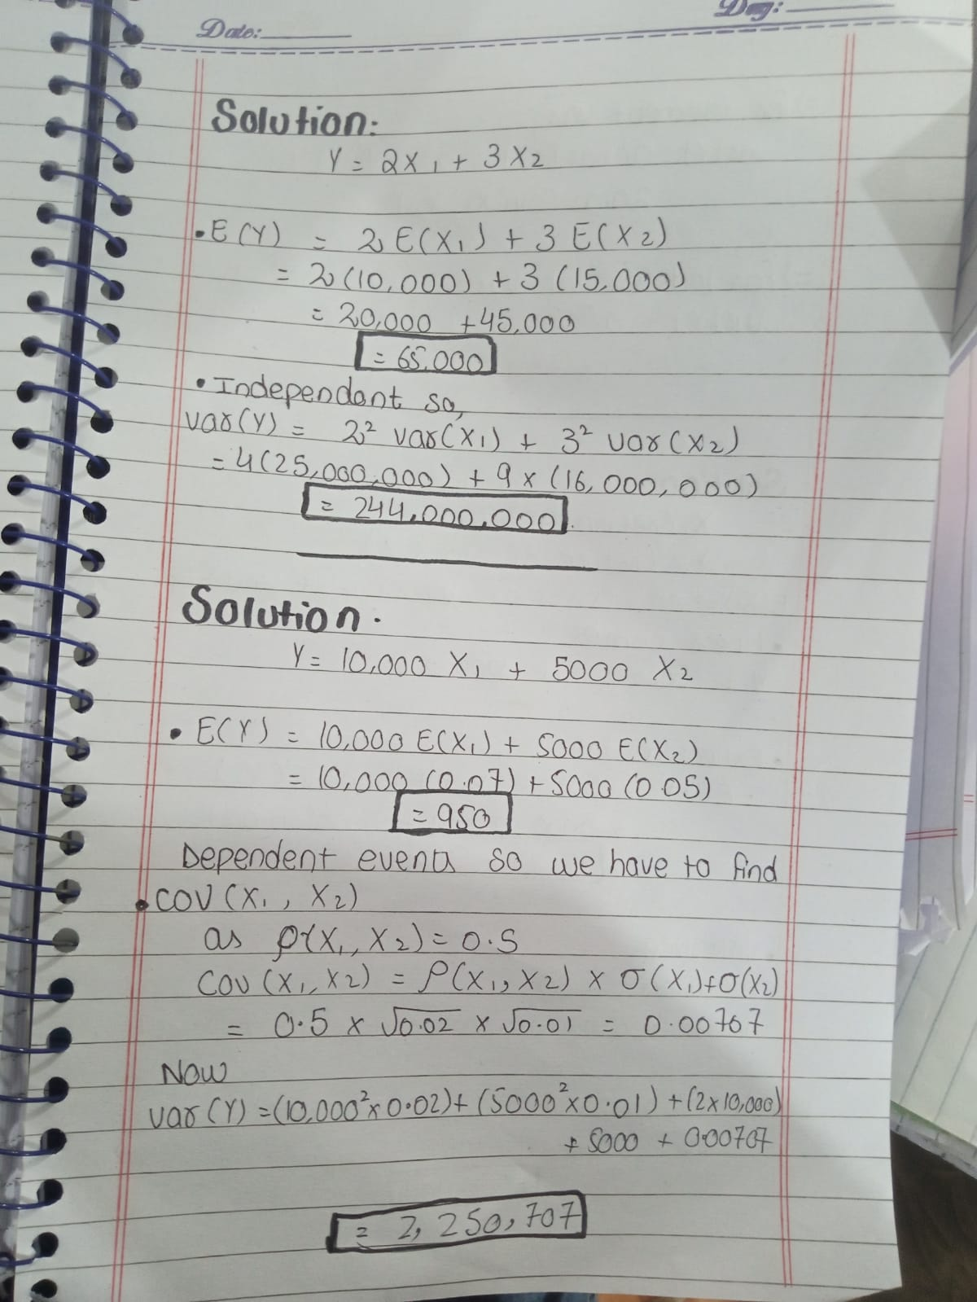

Practice Question 4:
You have two stocks in your portfolio: Stock A and Stock B. Let:
- X1​ be the return on Stock A, where E(X1)=0.07 and Var(X1)=0.02
- X2​ be the return on Stock B, where E(X2)=0.05 and Var(X2)=0.01
You invest $10,000 in Stock A and $5,000 in Stock B. If the correlation between the two stocks is 0.5, find the expected return and variance of your total portfolio return.44

